The User Manual of the HyperCast Simulator (LoTos)
Guangyu Dong, Multimedia Networks Group, May 2005

1. Install and Run
1.1 System requirement
The HyperCast Simulator requires Java version 1.4.x or higher. The system must have at least 30MB free memory and support graphic display.

1.2 Files organization
Suppose all simulator files are in “Simulator/” directory.
Simulator/: the source codes of HyperCast Simulator
Simulator/bin/: the output directory of the compilation done by running “make” command
Simulator/jars/: the directory for library packages and outputting jar file of HyperCast Simulator.
Simulator/javadoc/: the directory of the java docs.

1.3 Compiling
Run “make” under “Simulator/” to compile the HyperCast Simulator. The generated class files will be put in the “Simulator/bin/” directory, and the generated java doc files will be put in “Simulator/javadoc” directory. A “lotos.jar” package file is automatically generated under “Simulator/jars” folder.
Can also run “make jar” to generate a “lotos.jar” package file without recompiling the source codes.

1.4 Required library
Several library packages are required to compile and run the HyperCast Simulator. They are put in the /Simulator/jars/ directory:
- hypercast3.0.jar: the HyperCast 3.0 package, required to provide the implementation of several overlay protocols, such as Delaney Triangulation, Spanning Tree, and HyperCube.
- xalan.jar: provides the support of XPath API.
- bcprov-jdk14-122.jar: needed to simulate the security scheme in HyperCast.
- hypercast3.0-pastry.jar: provides the implementation of Pastry overlay protocol
- lotos.jar: this is the binary package of HyperCast Simulator.

1.5 Run the HyperCast Simulator
Type in the following line to run the HyperCast Simulator
java –cp <CLASSPATH> GUI

All the required library packages described in 1.4 must be specified in the <CLASSPATH>. We also provide two batch files to run the simulator:
lotos.bat (under MS Windows)
lotos.sh (under Unix/Linux)

1.6 Run the Simulator in an Internet browser.
The “lotos.html” file in the “Simulator/jars/” directory provides an example of how to run the HyperCast Simulator in an Internet browser. To use “lotos.html”, all the jar files must be in the same directory.
The Internet browser must use a JVM with Java version 1.4.x or higher, or the simulator will not load. To check what is the exact JVM version of you browser, use the browser to check this link: http://javatester.org/version.html

2. Graphic Interface
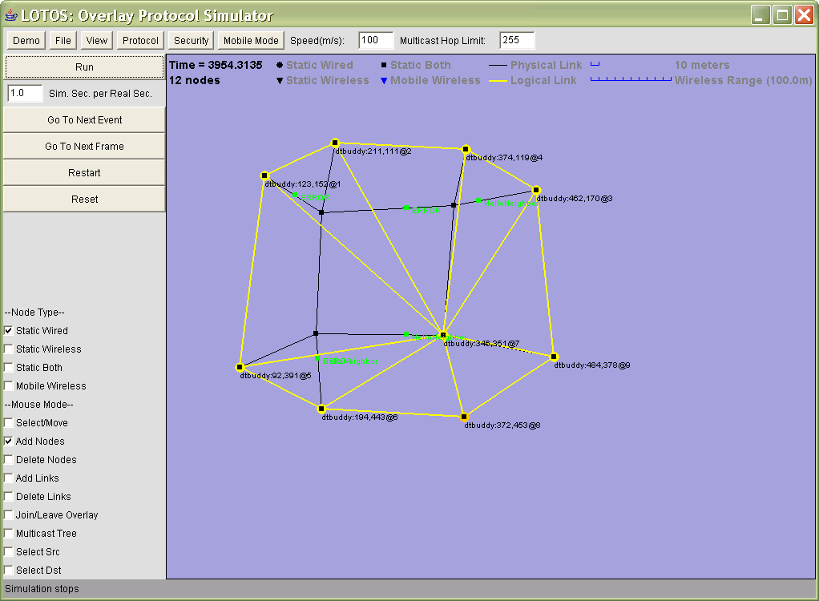

The graphic interface of the HyperCast Simulator looks like the figure above. The functions of different parts of the interface are described below.

2.1 Toolbar
The toolbar includes a serial of buttons, each of which will trigger a popup menu when clicked. The “Speed” field sets the speed of ALL mobile nodes in the overlay network in the form of “meters per second”. The “Multicast Hop Limit” field sets the maximum TTL of a multicasting message in the substrate network.
2.2 Main menus
Demo: this menu show a list of preset physical and overlay network settings. It’s for those people who don’t want to explore the complexity of creating a network by hand and want to see the simulation quickly. See section 3.3 about how to customize this menu.

File: this menu deals with saving and loading the substrate and logical network settings. It will not be shown if this program is run as an Applet. The user can choose to save/load only the substrate or logical network, or both. The network is saved to a XML file whose name is given by the user.

View: this menu deals with the how the overlay network is displayed on the window. User can choose to zoom in, zoom out or scale to fit the screen. The user can also select which item should be shown and which item should not by toggling the checkbox items on shown on the view menu.

Protocol: this menu shows a list of HyperCast protocols that can be simulated in the LoTos. When a protocol on this menu is checked, the next node that is activated will use this protocol. If some nodes are selected by mouse when the user clicks to select a protocol, those selected nodes will be changed to use the selected protocol. See section 3.1 to learn how to customize this menu.

Security: this menu show a list of HyperCast security setting that can be simulated in the LoTos. When a security setting on this menu is checked, the next node that is activated will use this security setting. If some nodes are being selected by mouse when the user clicks to select a security setting, those selected nodes will be changed to use this selected security setting. See section 3.2 to learn how to customize this menu.

Mobile Mode: this menu chooses the mobility mode of the node added to the network. Currently there’s only one mobile mode “Linear Motion”.

2.3 Simulating buttons
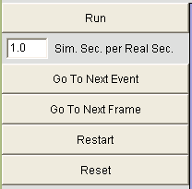
These buttons control the simulations.
Run: start run or pause the simulation
Simulation speed: set the number of simulation seconds for every real second.
Go To Next Event: run the simulation until there a message is sent or received.
Go To Next Frame: run the simulation until the next time frame.
Restart: reset simulation clock to 0 and reset all protocol nodes.
Reset: reset simulation clock to 0 and clear every thing in the network

2.4 Node type selection
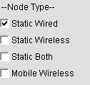
These checkbox are used to select the type of substrate nodes added to the network. The are useful only when the “Mouse Mode” is set to “Add Nodes”.

2.5 Mouse mode selection
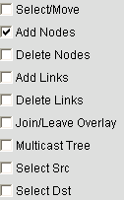
These items are used to select the mouse operation mode.
Select/Move: when selecting this item, the mouse can be used to select or move nodes on the window. Left click the node to select it, and hold the “CTRL” key to select multiple nodes. When a node is selected, a red circle is displayed to surround the node. User can also draw a rectangle on the window to select multiple nodes. The user can use the left button of mouse to drag the selected nodes to move them around.

Add Nodes: When user left click on the window, a new substrate node will be added. If a protocol item in the protocol menu is selected, a protocol node is also created and put on the new substrate node.

Delete Nodes: User left clicks a node to remove both the substrate and protocol node.

Add Links: User drags the mouse from one substrate node to another to draw a network link between them. Both nodes must have a wired interface, that is, they must be either “Static Wired” or “Static Both” type.

Delete Links: Click on the network link to delete it.

Join/Leave Overlay: Click on a substrate node to add or remove an protocol node.

Multicast Tree: Click on a protocol node to see the multicast distribution tree sourced at this node.

Select Src: Click on a protocol node to choose the source of a unicast path. If both source and destination is selected, a unicast route between them is displayed if it is available.

Select Dst: Click on a protocol node to choose the destination of a unicast path. If both source and destination is selected, a unicast route between them is displayed if it is available.

2.6 Popup menu
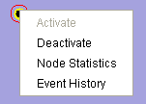

Whenever user right-clicks a node, a popup menu is shown:
Activate: if there is no protocol running, this will add a protocol node on the substrate node using the protocol checked in the protocol menu.

Deactivate: remove the protocol node if there is one.

Node Statistics: show a dialog that accesses the statistics of the I_Node object.

Event History: show a dialog that shows the event history of the protocol node. The events recorded includes timer, messages sent and message receives. The maximum size of this history is set to 100.

3. Customize
3.1 Adding new protocol
3.1.1 Requirement of the protocol
A protocol that can be simulated in the LoTos simulator must implement the I_Node interface, and is designed to work in the way as a normal HyperCast protocol node. Furthermore, there are several rules that the protocol implementation must obey in order to be correctly simulated in LoTos:
1. The protocol implementation must only initialize and start to run (e.g, set new timer, and sends out message) in after the joinOverlay() method is called. Particularly, don’t try to start things in the constructor of protocol node class.
2. After leaveOverlay() method is called, the protocol node must stop doing anything, including handling timer and message. And it must know that the timer will be cleaned up after this method is called.
3. The protocol node should not assume there are separate threads for timers and messages. As a result, using wait() or notify() functions to do synchronization is inappropriate.
4. All the related protocol message classes should implement the toString() method to return a short label of the message. This label will be displayed on the simulator GUI interface to show the type of the messages being transmitted in the network

3.1.2 Create Agent class
The first step of adding a new protocol to the simulator is to create a class implementing I_SimHyperCastAgent interface. This class works as a bridge between a HyperCast protocol node. The definition and description of this interface are shown below.

public interface I_SimHyperCastAgent {

/**
* Get the name of this protocol. This name will work as an identifier
* of this protocol. But this name is not the text that finally shown
* in the protocol menu because different protocol menu item might share
* the same agent class.
*
* @return the name for the protocol
*/
public String getName();
/**
* Set the network object. The implementation might need this object to
* access some global information sometime. For example, through this
* network object, all the nodes in the network can be accessed.
*
* @param network
*/
public void setNetwork(simHCNetwork network);
/**
* create the next I_Node object to be put into the simulator.
*
* If needServers() return true, then this function create a server node
* that is needed to run the protocol.
*
* This function is called when user tries to add a protocol node into
* the simulated overlay network.The I_Node object being created will be
* put on a existing physical node on the simulator GUI interface
*
* The "info" argument is used to restore a saved protocol node from
* a file. And the value of "info" was originally obtained by calling
* the getInfo() method of this interface. Basically, a "info" string
* returned by a getInfo() method should contain all the information
* enough to create an completely identical I_Node object using
* createNode() method.
*
* @param coords the position of this node on the LoTos window
* @param adapter the node adapter to be used by the new node
* @param info if is not null, use this info to create a new node
* @return the new I_Node object
*/
public I_Node createNode(XYAddress coords, HyperCastConfig config, I_UnicastAdapter adapter, String info);

/**
* Check if need to create some servers before running the protocol.
* If the result is true, those servers can be created one by one by
* calling the createNode() method.
*
* A DT server is an example of such kind of a server.
*
* @return true if the protocol need supports from one or more servers
*
*/
public boolean needServers(HyperCastConfig config);
/**
*
* The "info" argument is used to restore a saved protocol node from
* a file. And the value of "info" was originally obtained by calling
* the getInfo() method of this interface. Basically, a "info" string
* returned by a getInfo() method should contain all the information
* enough to create an completely identical I_Node object using
* createNode() method.
*
* @return
*/
public String getInfoForNode(I_Node node);

/**
* Get the labels of the menu items for this protocol if it has need
* to define protocol dependent operations for protocol nodes created
* by this agent class.
*
* There should not have duplicate menu names in this list
*
* @return a list of menu item label
*/
public String [] getMenuItems();

/**
* Fires the menu item by the menu item's label.
*
* This method defines the operations corresponding to the popup menu
* items defined by the getMenuItems() function.
*
* @param menu
*/
public void menuFired(String menu);

/**
* Get the color for a I_Node object. The resulting color should depends on
* the current state of the node.
*
* @param node
* @return
*/
public Color getColorForNode(I_Node node);

/**
* Get the shape for a I_Node object. The resulting shape should depends on
* the type of the node.
*
* @param node
* @return
*/
public int getShapeForNode(I_Node node);

/**
* Get the display label for a node.
*
* @param node
* @return
*/
public String getLabelForNode(I_Node node);

/**
* Called when a protocol node is removed from LoTos. The method tell the agent
* when a protocol node is removed from the overlay network such that the agent
* can do things correspondingly. For example, if a DT server is removed, the
* agent is informed by thie function and will create another DT_Server next
* time the createNode() method is called.
*
* @param node
*/
public void nodeRemoved(I_Node node);

}

An agent class deals with creating new I_Node objects to be simulated in the LoTos. The servers that need to be run to support the protocol should also be implemented as an I_Node class, and the server objects should be created before any other normal protocol I_Node is created (see createNode() and needServer() methods). An agent class should store the server objects that was created in order to check if they are removed in the implementation of nodeRemoved() method.
An agent class also tells the GUI interface how a protocol node is displayed on the GUI window using getColorForNode(), getShapeForNode() and getLabelForNode() methods.
The getInfoForNode() method is used to generate a text string that can be used to save the protocol node to a file and restore it later. The info string should contain all the information that is enough to restore the protocol node later in the same agent object.

3.1.3 Modify configuration file
After an agent class is created, the next step of adding a protocol into LoTos is to add an entry to the protocol configuration file SimHypercast.xml. Suppose the agent class we created is call DTBuddyListAgent, below is an example of how to add this agent class into the configuration file:

<SimHypercast>
… …
<!-- the name field will appear on the protocol menu -->
<HypercastProtocol name="DTBuddyList">
<!-- the agent class name -->
<AgentClass>DTBuddyListAgent</AgentClass>
<Properties>
<Public>
<Node>
<DTBuddyList>
<!-- the attributes for the DTBuddyList node -->
….
</DTBuddyList>
</Node>
</Public>
</Properties>
</HypercastProtocol>
… …
</SimHypercast>

The name attribute in the “HypercastProtocol” element will become an item in the protocol menu. The “AgentClass” item specifies the name of the agent class we have defined as the bridge between the LoTos and protocol node objects. The configuration attributes for the protocol nodes are enclosed in the “Properties” element.
An agent class can have multiple “HypercastProtocol” entries in the SimHypercast.xml file in order to simulate the same protocol with different configuration attributes. But different protocol setting need to be given different name in order to be distinguished in the protocol menu.

3.2 Adding new security setting
Different security setting can be added by editing the SimHypercast.xml configuration files, an example is shown below:

<SimHypercast>
<!-- the name field will appear on the security menu -->
<SecuritySetting name="NeighborhoodKeys-1">
<Properties>
<Public>
<Security>
<!-- below is the public attributes for the security -->
<KeyModeMethod>NeighborhoodKeys-1</KeyModeMethod>
<SecurityLevel>privacy</SecurityLevel>
<CertificateLocation>testcert.cer</CertificateLocation>
… …
</Security>
</Public>
</Properties>
<!-- below is the private attributes for the security -->
<PrivateProperty XPath="/Private/KeyStorePassword" value="password"/>
<PrivateProperty XPath="/Private/PrivateKeyAlias" value="testpair"/>
<PrivateProperty XPath="/Private/PrivateKeyPassword" value="password"/>
<PrivateProperty XPath="/Private/GroupKey" value="1234567812345678"/>
</SecuritySetting>
</SimHypercast>

3.3 Adding new demo item
3.3.1 Generate a demo setting
The first step to add a new demo is to manually construct an physical and logical network setting on the LoTos GUI window. Try to add nodes, link into the window, and activate some protocol nodes using appropriate protocol and security setting. Goto the menu “File->Save All” to save the network setting to a file, for example “demo1.xml”.

3.3.2 Add to demo menu
Edit “DemoMenuConfig.xml” and add following item:

<DemoMenu>
<!-- the name field will become a item in the Demo menu -->
<Demo name="DTBroadcast Demo">
<FileName>demo1.xml</FileName>
</Demo>
</DemoMenu>

